**SAMPLE MCQ QUESTIONS**

1. How is sampling been done when an image is produced by a solitary sensing component joined with mechanical motion?

A. The number of sensors in the strip defines the sampling limitations in one direction and Mechanical motion in the other direction.

B. The number of sensors in the sensing array establishes the limits of sampling in both directions.

**C. The number of mechanical increments when the sensor is activated to collect data.**

D. None of the mentioned.

2. In which step of processing, the images are subdivided successively into smaller regions?

**A. Wavelets**

B. Image enhancement

C. Image acquisition

D. Segmentation

3. What is the expansion of JPEG?

A.  Joint Photographic Expansion Group

B. Joint Photographs Expansion Group

C. Joint Photographic Expanded Group

**D. Joint Photographic Experts Group**

4. which of these equations used to obtain S component of every RGB pixel in RGB color format?

A. 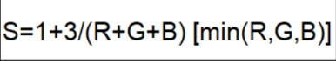

B. 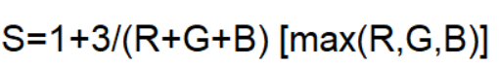

C. 

**D.** 

5. The parameter to distinguish between colors is

A. hue

B. saturation

**C. Both a and b**

6. What is a stream or river that feeds into a larger body of water?

**A. Tributary**

B. Bay

C. Estuary

D. Watershed

7. For diagonal edge detection we use

A. 1D mask

**B. 2D mask**

C. 3D mask

D. 4D mask

8. In Delta Rule for error minimization

A. weights are adjusted w.r.to change in the output

**B. weights are adjusted w.r.to difference between desired output and actual output**

C. weights are adjusted w.r.to difference between input and output

D. none of the above

9. A spatial domain filter of the corresponding filter in frequency domain can be obtained by applying which of the following operation(s) on filter in frequency domain?

A. Fourier transform

**B. Inverse Fourier transform**

C. None of the mentioned

D. All of the mentioned

10. Which of the accompanying assertions is not correct concerning the Advanced Differential Analyzer (DDA) calculation?

A. Scan Line conversion

**B. Draw circle**

C. Calculation of intermediate steps.

D. None of the above